1. Create an html page to display the following nested list

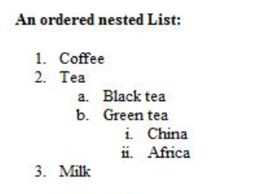

<html>

<head>

</head>

<body>

<b>An ordered nested List :</b>

<ol>

<li>Coffee</li>

<li>Tea</li>

<ol TYPE="a">

<li>Black tea</li>

<li>Green tea</li>

<ol TYPE="i">

<li>China</li>

<li>Africa</li>

</ol>

</ol>

<li>Milk</li>

</body>

</html>

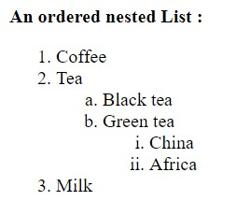

1. Create links to three different pages on three different websites that should all open in a new window.

<html>

<head>

</head>

<body>

<br><br>

<a href="https://www.upsc.gov.in/" target="_blank">Union Public Service Commission</a>

<br><br>

<a href="http://www.weather.com/" target="_blank">Weather Report</a>

<br><br>

<a href="https://github.com/" target="_blank">GitHub</a>

</body>

</html>



1. Create a page with a link at the top of it that when clicked will jump all the way to the bottom of the page.

<html>

<head>

</head>

<body>

The top of the page&nbsp;&nbsp;&nbsp;&nbsp;&nbsp;&nbsp;<a href="#bottom" name="top">GoTo Bottom</a><br>

One<br>

Two<br>

Three<br>

Four<br>

Five<br>

Six<br>

Seven<br>

Eight<br>

Nine<br>

Ten<br>

One<br>

Two<br>

Three<br>

Four<br>

Five<br>

Six<br>

Seven<br>

Eight<br>

Nine<br>

Ten<br>

One<br>

Two<br>

Three<br>

Four<br>

Five<br>

Six<br>

Seven<br>

Eight<br>

Nine<br>

Ten<br>

One<br>

Two<br>

Three<br>

Four<br>

Five<br>

Six<br>

Seven<br>

Eight<br>

Nine<br>

Ten<br>

One<br>

Two<br>

Three<br>

Four<br>

Five<br>

Six<br>

Seven<br>

Eight<br>

Nine<br>

Ten<br>

One<br>

Two<br>

Three<br>

Four<br>

Five<br>

Six<br>

Seven<br>

Eight<br>

Nine<br>

Ten<br>

<a name="bottom">The bottom of the page</a>

&nbsp;&nbsp;&nbsp;&nbsp;&nbsp;&nbsp;

<a href="#top">GoTo Top</a>

</body>

</html>

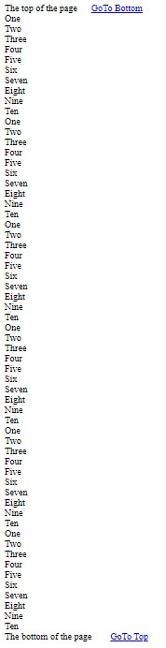

1. Display three different images. Skip two lines between each image. Each image should have a heading.

<html>

<head>

</head>

<body>

<br><br>

<imgsrc="bird.jpeg" alt="bird" title="Bird" width="200px" height="200px">

<br><br>

<imgsrc="Cat.jfif" alt="Cat" title="Cat" width="200px" height="200px">

<br><br>

<imgsrc="flower.jpeg" alt="flower" title="Flower" width="200px" height="200px">

</body>

</html>

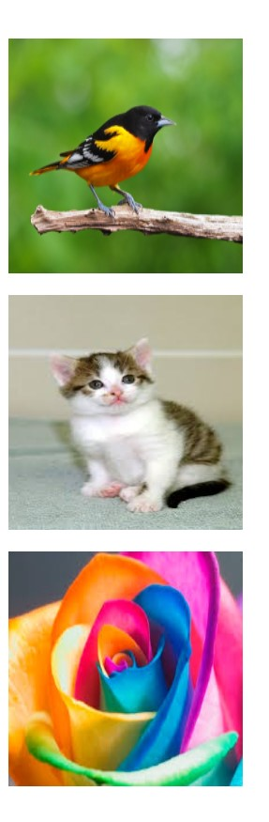

1. Display an image that when clicked will link to a search engine of your choice in a different window.

<html>

<head></head>

<body>

<br><br>

<center>

<a href="https://www.google.com/" target="_blank">

<imgsrc="google.jpeg" alt="GOOGLE" width="400px" height="200px">

</a>

<p>Click the image to Go to Google search engine.</p>

</center>

</body>

</html>



1. Create the following Html Page using appropriate form controls.

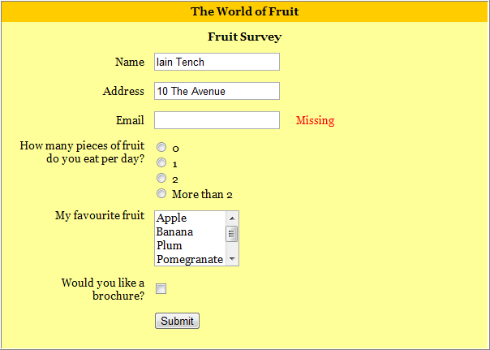

<html>

<head>

<style>

.div_1{background-color:orange;margin:20px;}

.div_2{background-color:yellow;margin:20px;}

</style>

</head>

<body>

<center>

<div class="div_1"><font size="4" face="Cooper"><hl>The World of Fruit</hl></font></div>

<div class="div_2">

<form method="post">

<font size="4" face="Cooper"><hl align="center">Fruit Survey</hl></font>

<table align="center">

<tr>

<th>Name</th>

<td><input type="text" name="name" style="width:400px;" class="form-control" required=""></td>

</tr>

<tr>

<th>Address</th>

<td><input type="text" name="address" style="width:400px;" class="form-control" required=""></td>

</tr>

<tr>

<th>Email</th>

<td><input type="text" name="Email" style="width:400px;" class="form-control" required=""></td>

</tr>

<tr>

<th>How many pieces of fruit<br>do you eat per day?</th>

<td><input type="radio" name="0" value="0">0<br><input type="radio" name="1" value="1">1<br><input type="radio" name="2" value="2">2<br><input type="radio" name="More than 2" value="More than 2">More than 2

</tr>

<tr>

<th>My Favorite fruit</th>

<td><textarea rows="4" cols="12" name="favorite fruit" style="overflow-y: scroll;">Apple Banana Plum Pomegranate Orange </textarea>

</td>

</tr>

<tr>

<th>Would you like a<br>brochure?</th>

<td><input type="checkbox" name="yes" value="on"></td>

</tr>

<tr>

<tdalign="center" colspan="2"><input type="submit" name="submit" value="submit"></td>

</tr>

</table>

</form>

</div>

</center>

</body>

<html>

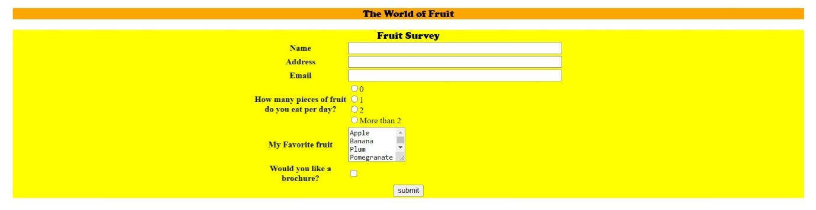

1. Create an image map for ‘Kerala Map’. Map at least 3 districts so that when you click on that particular district the details regarding that district(eg: population, Area, Tourist Spots(with images), Monuments, Interesting Facts ) should be displayed on a new page.

<html>

<head>

</head>

<body>

<center>

<h1><u><font color="grey" face="Cooper">KERALA MAP</font></u></h1>

<map name="kerala">

<area shape="circle" coords="353,456,50" href="kottayam.html"/>

<area shape="circle" coords="270,159,50" href="wayanad.html"/>

<area shape="circle" coords="411,407,50" href="iduki.html"/>

</map>

<imgsrc="kerala.jpeg" alt="kerala" usemap="#kerala"/>

</center>

</body>

</html>

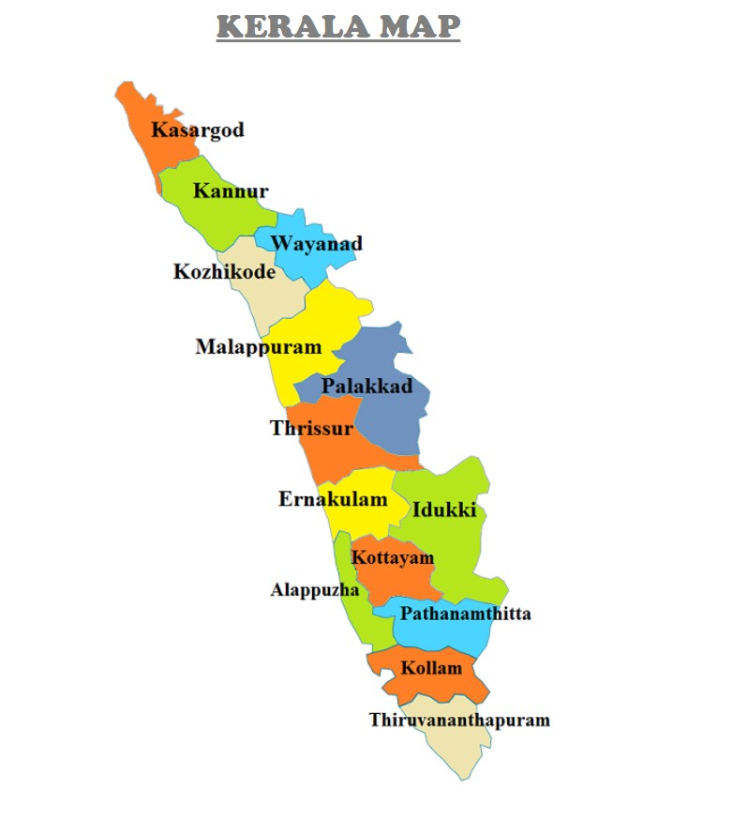

1. Construct this puzzle looking thing.

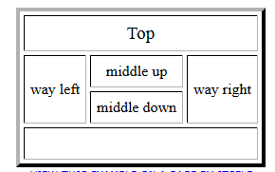

<html>

<body>

<table border="3">

<tr>

<td colspan="3" align="center">

Top

</td>

</tr>

<tr>

<td rowspan="2" align="center">

way left

</td>

<tdalign="center">

middle up

</td>

<td rowspan="2" align="center">

way right

</td>

</tr>

<tr>

<tdalign="center">

middle down

</td>

</tr>

<tr>

<td colspan="3" style="height:22px;">

</td>

</tr>

</table>

</body>

</html>

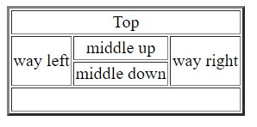

1. Make up three image links for 3 web browsers and put them in a borderless table. Construct the table so that there is just a little space between the images.

<html>

<head>

</head>

<body>

<br><br>

<table align="center" style="border-collapse : collapse;">

<tr>

<td><a href="https://www.firefox.com/" target="_blank">

<imgsrc="firefox.jpeg" alt="firefox" height="220" width="350"></a>FIREFOX

</td>

</tr>

<tr>

<td><a href="https://www.google.com/chrome/" target="_blank">

<imgsrc="chrome.jpeg" alt="chrome" height="220" width="350"></a>GOOGLE CHROME

</td>

</tr>

<tr>

<td><a href="https://microsoft.com" target="_blank">

<imgsrc="explorer.jpeg" alt="edge" height="220" width="350"></a>INTERNET EXPLORER

</td>

</tr>

</table>

</body>

</html>

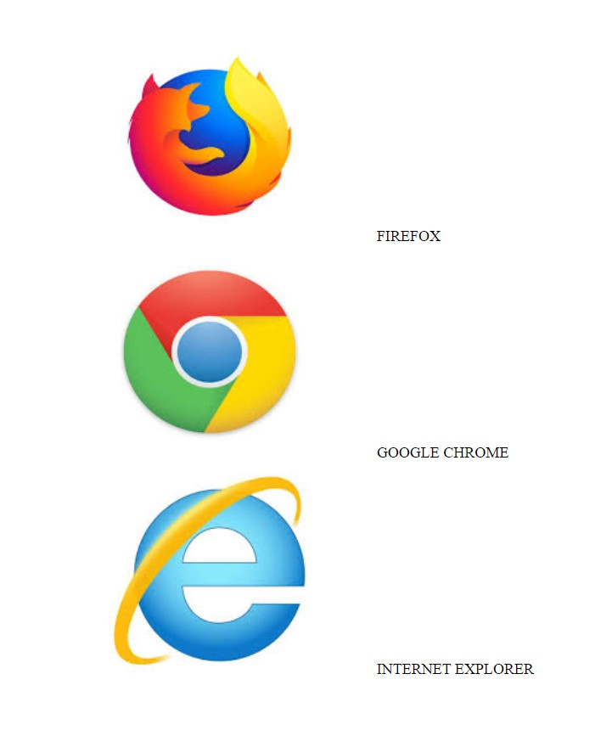

1. Create the following html page using frames.

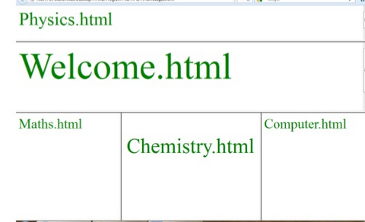

<html>

<frameset rows="15%,25%,*" border="3">

<frame src="physics.html">

<frame src="welcome.html">

<frame src="frame3.html">

</frameset>

</html>

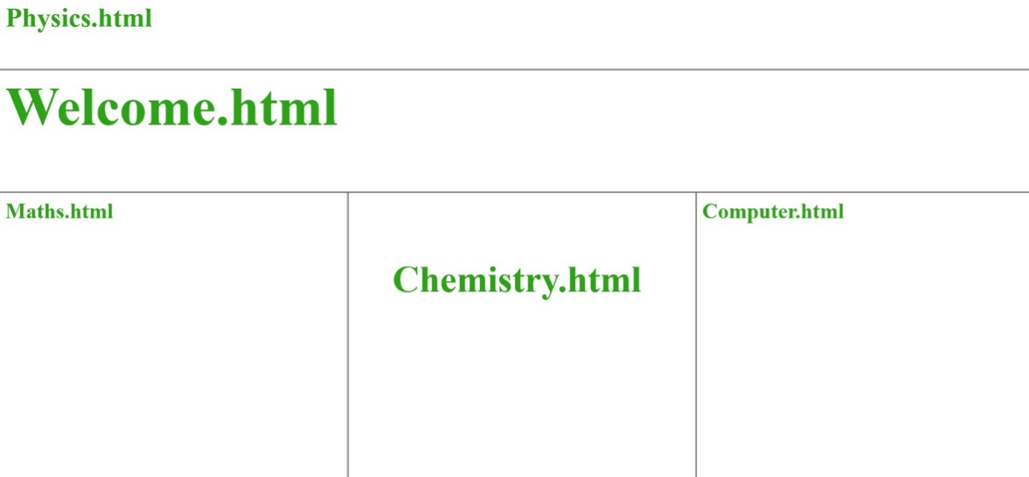

11. Create an HTML page using frames which is similar to the following one.

In the left frame provide hyperlinks to 3 important monuments in world. On clicking that hyperlink an image of the monument should be displayed in right frame with suitable description.

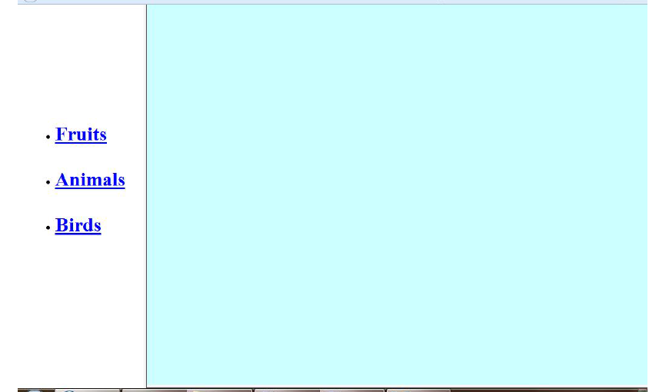

<!DOCTYPE html>

<html>

<head>

<title> navigation </title>

</head>

<frameset cols="25%,*">

<frame src="link.html"/>

<frame src="home.html"name="z"/>

</frameset>

<body>

</body>

</html>

